3.5" External SATA Hard Disk ENCLOSURE

Simply Add Your Own 3.5" Hard Disk
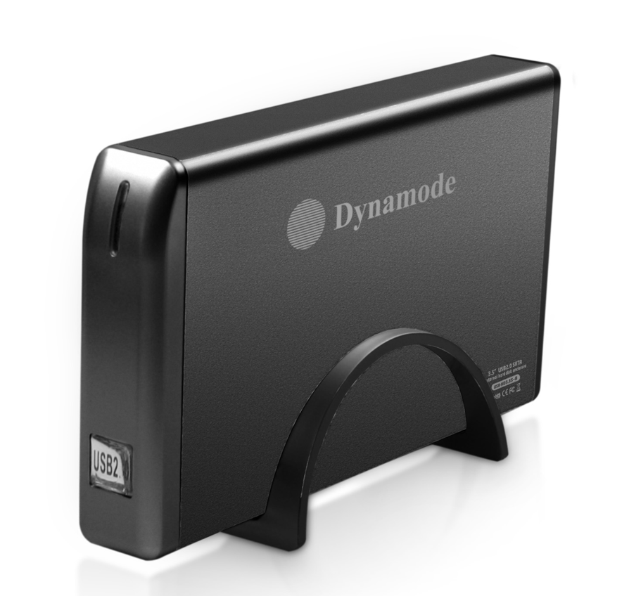

DESCRIPTION
The exciting new USB-HD3.5-B is a stylish, high quality aluminium Disk Enclosure with totally silent operation. The newly designed Aluminium enclosure acts as a built-in heatsink, effectively reducing heat output of the enclosed Hard Disk to enhance reliability and lifespan.

Fully Plug n' Play for leading Operating Systems including MicrosoftTM Windows and MACTM OS X, the USB-HD3.5-B allows your existing 3.5" IDE Hard Disk to be fitted quickly and with minimal effort. Enjoy fast data transfer speeds courtesy of the USB2.0 interface and immediate data transfer to and from your PC, Notebook or MAC.
FEATURES
> Stylish and portable aluminum design
> Ideal for your existing 3.5" IDE interfaced hard disk drives
> Re-use your PC, Server or Mac hard disk and keep your data
when you upgrade
> Plug n' Play for popular Operating Systems -
no drivers needed
> External PSU supplied
> Backup and restore your data at up to 480Mbps

SPECIFICATIONS
Transfer interface: USB2.0
Transfer data: 480Mbps(MAX)
Hard disk type: 3.5" IDE interfaced hard disk
Working temperature: -40 ~ 65℃
Working humidity: 8% ~ 90%
Storage humidity: 5% ~ 95%
Operating systems: Windows98/ME/2000/XP/VISTA/7/8/10, Mac OS 8.6 or above

